|  |  |
| --- | --- |
| **[Project] – External Document** |  |
| COMP6144  Web Programming |
| Odd Semester Year 2020/2021 |

* Project Title

$okopedia

* Introduction

**$okopedia** is a famous Indonesian technology company specializing in e-commerce, to expand its business, **$okopedia** wants to create a website for their shop. In that website, people can find information about the **$okopedia**’s products and order it. This website enables the customers to know what is inside **$okopedia**.

* Report / Documentation

1. Register

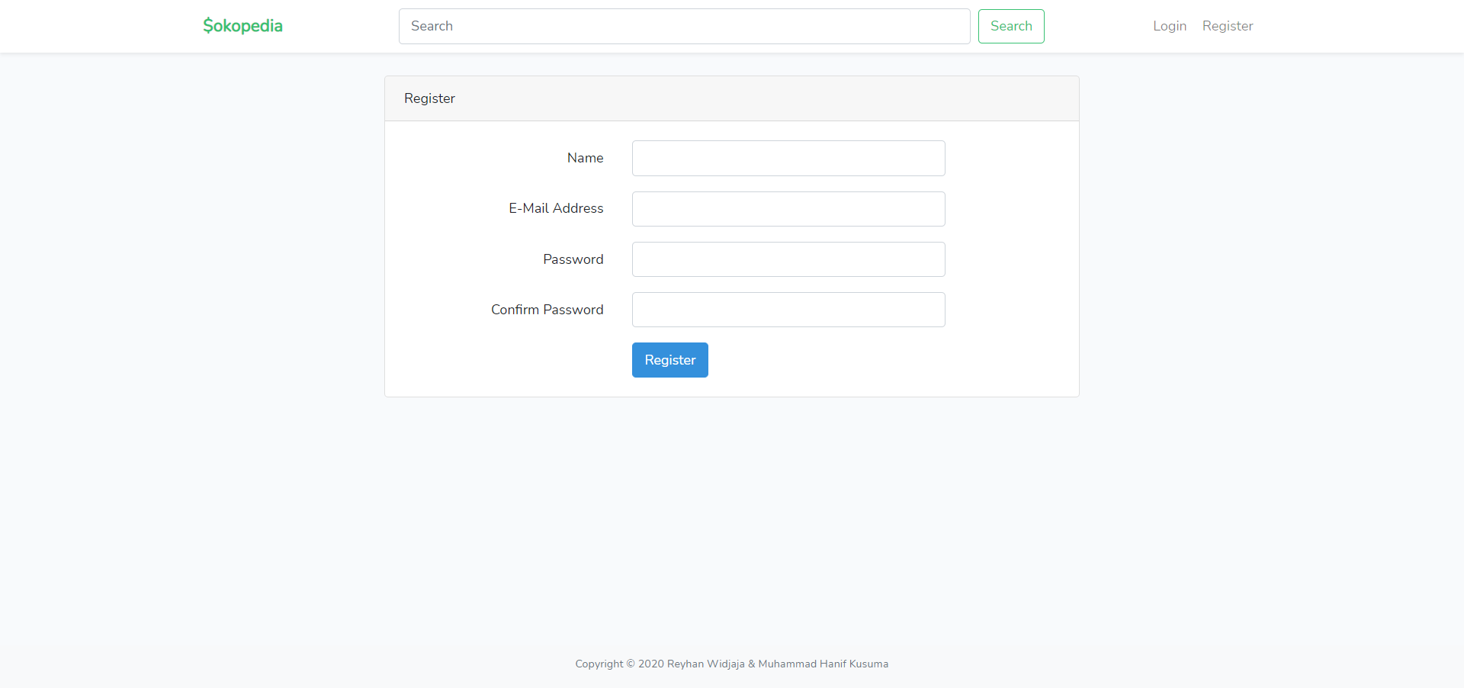

This page allows guests to **register** themselves as **$okopedia** member. To be able to **access the admin page** please register using **@sk-admin** email (ex. admin**@sk-admin**.com).

1. Login

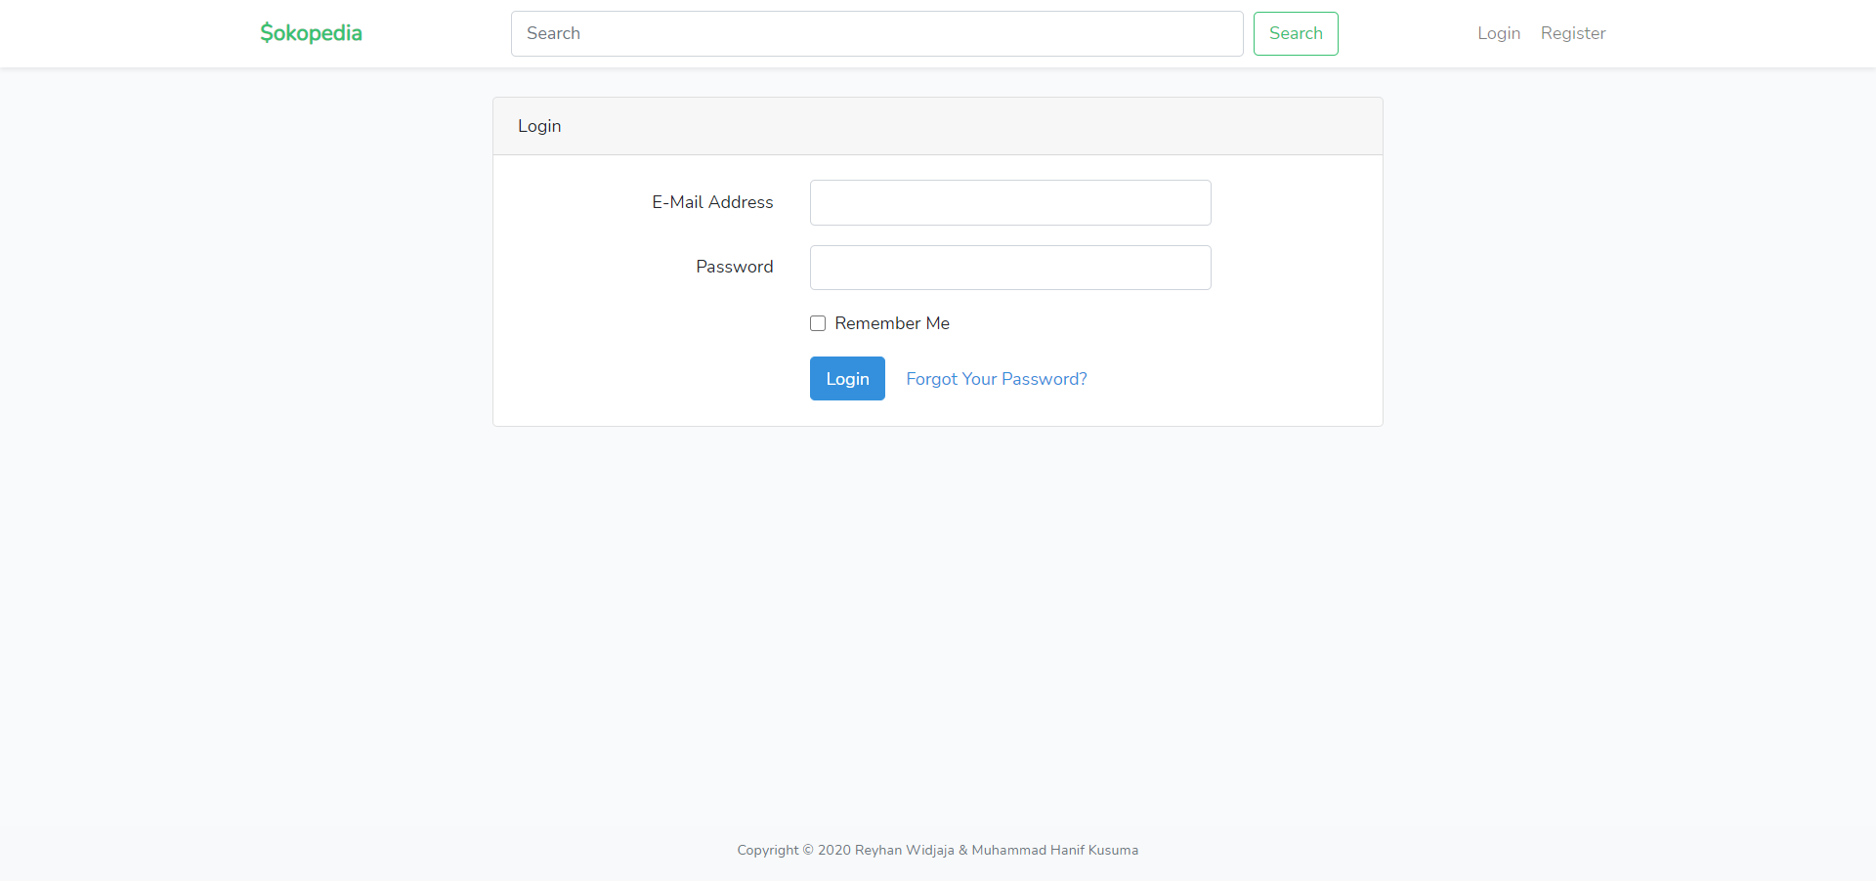

This page allows user to log in to the website. If user has entered correct **Username** and **Password**, the page will be redirected to the **Home Page**.

1. Home

**(guest)**

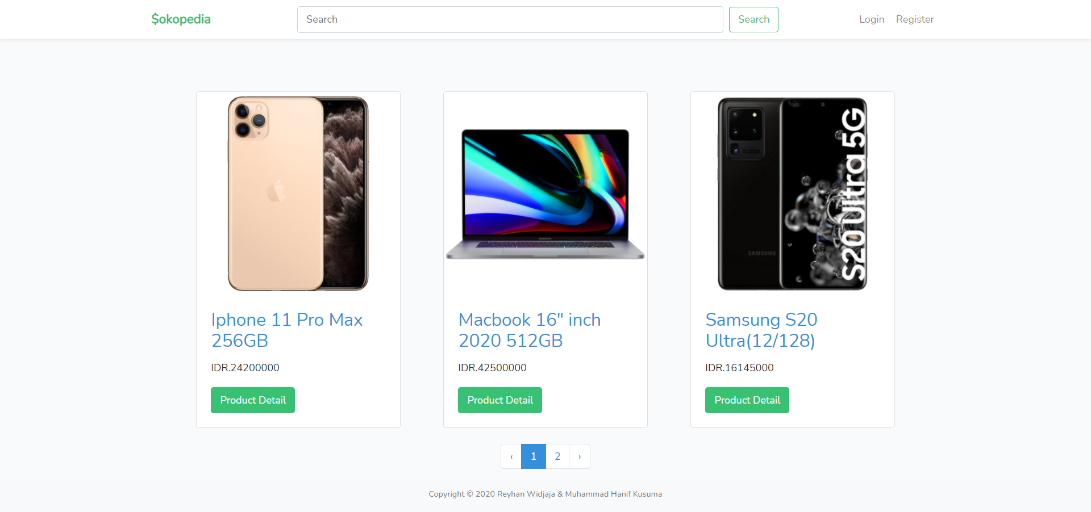

**(member)**

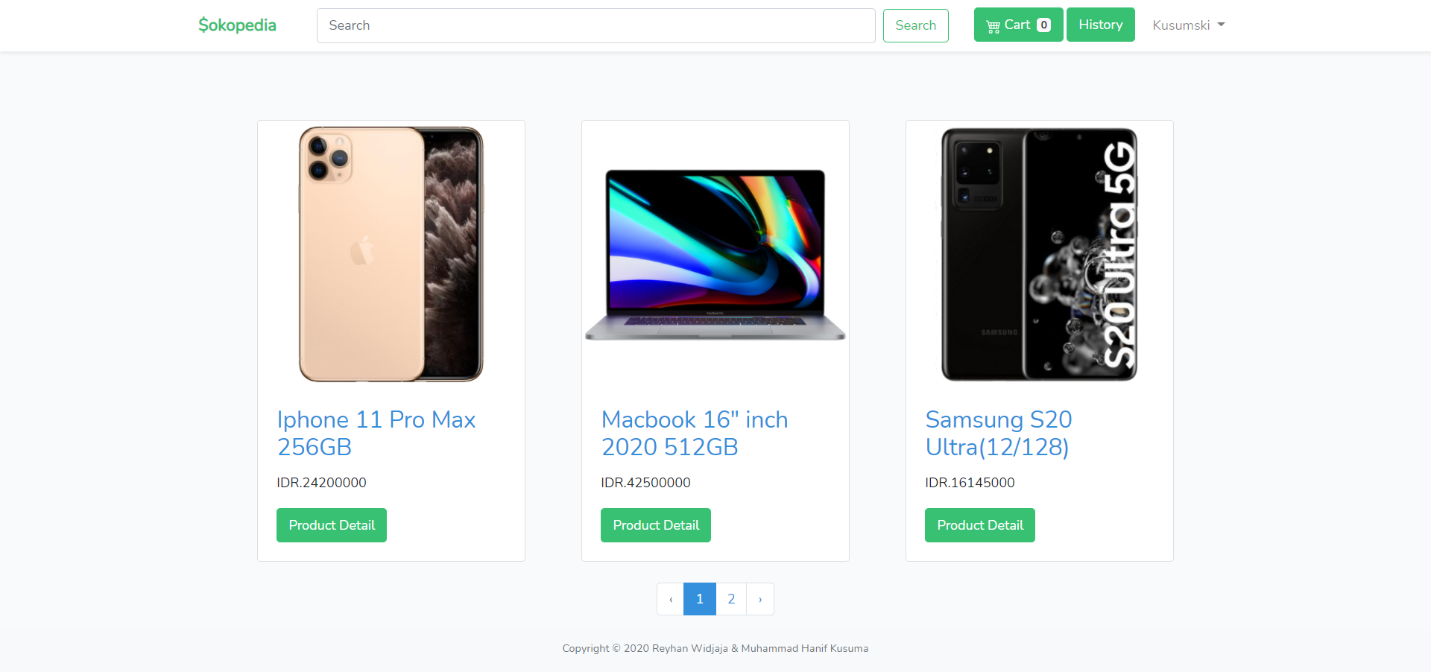

**(admin)**

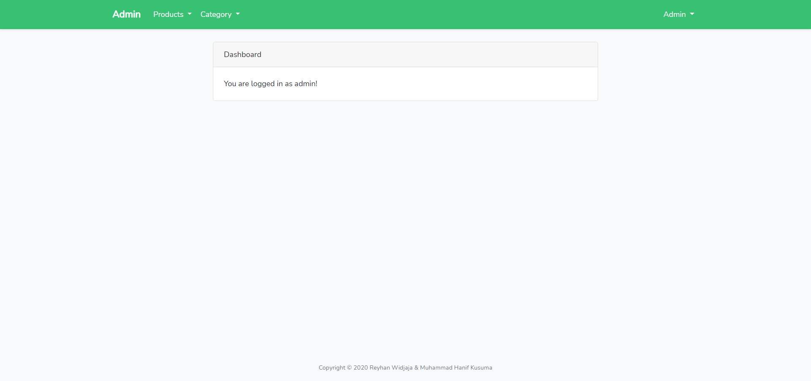

This page allows user to see all **$okopedia products**. This page is accessible for **all user.** In this page User can also **search by name of product and products paginate by 3.** In this page, guest can **Login** or **Register, this page can be accessed by all users.**

Logged in member will have extra button next to Search button, which is **cart** and **history** and the logged in username. **As for member, each product can be clicked to redirect into “Product’s Detail Page”.**

Admin will have extra button in the profile dropdown to switch between the member view and admin view.

1. Product Detail

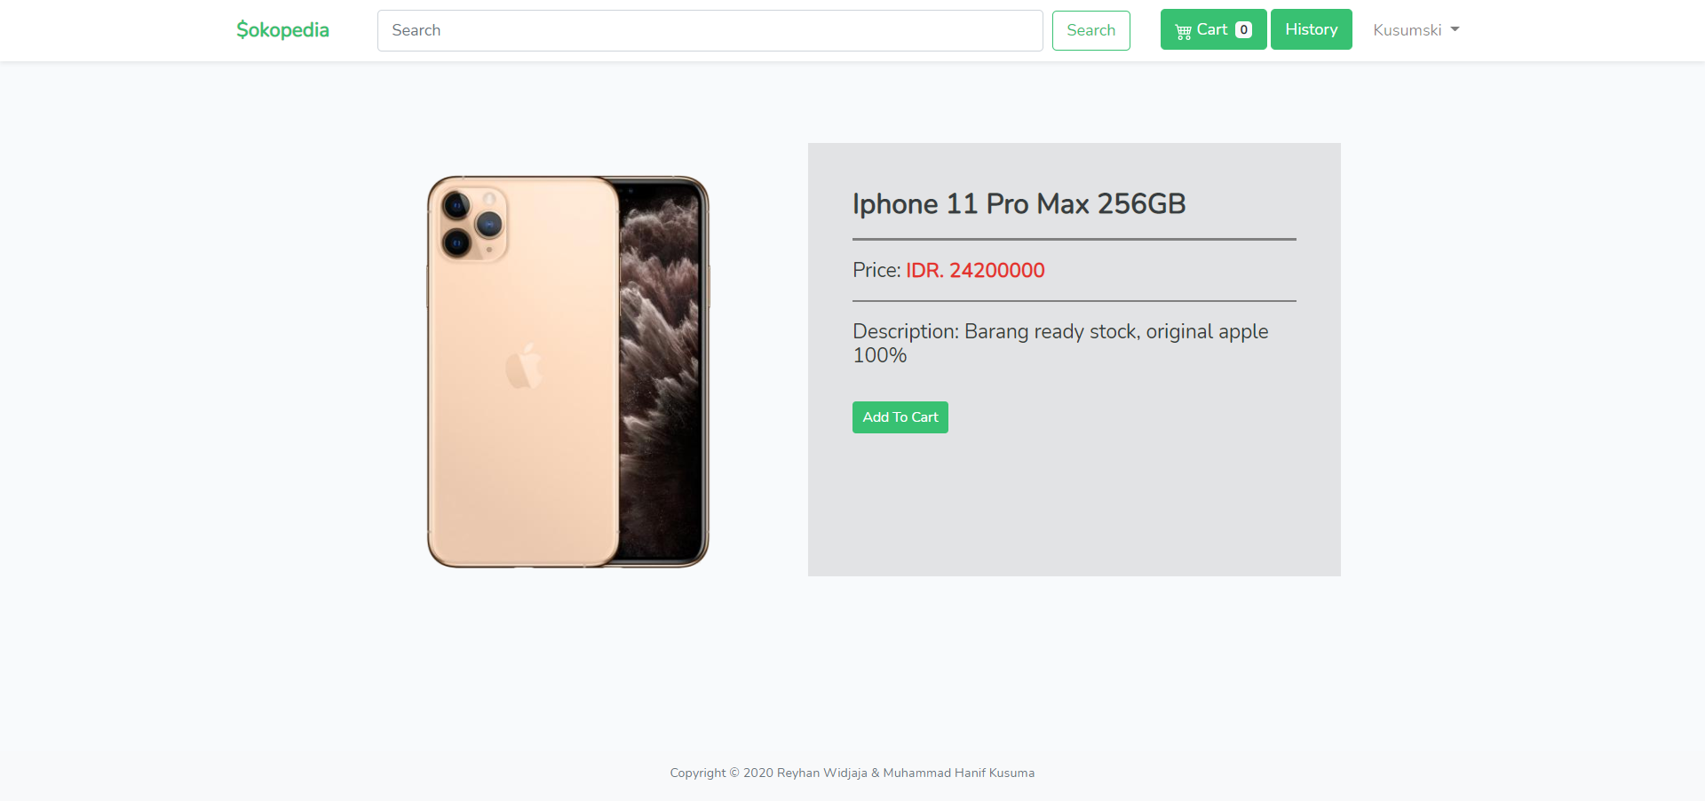

This page is accessible for **member only**. If guest trying to access this page, they will be redirected to **Login Page** before access **Product Detail Page**. This page shows product’s detail based on product clicked. This page is also **included with a search field**, so users can search $okopedia’s products **by Product’s Name**. **This page displays Product’s image, name, price, and description.**

In this page, there is **add to cart button** that can be clicked and redirect to “**add to cart page”**

1. Add to Cart

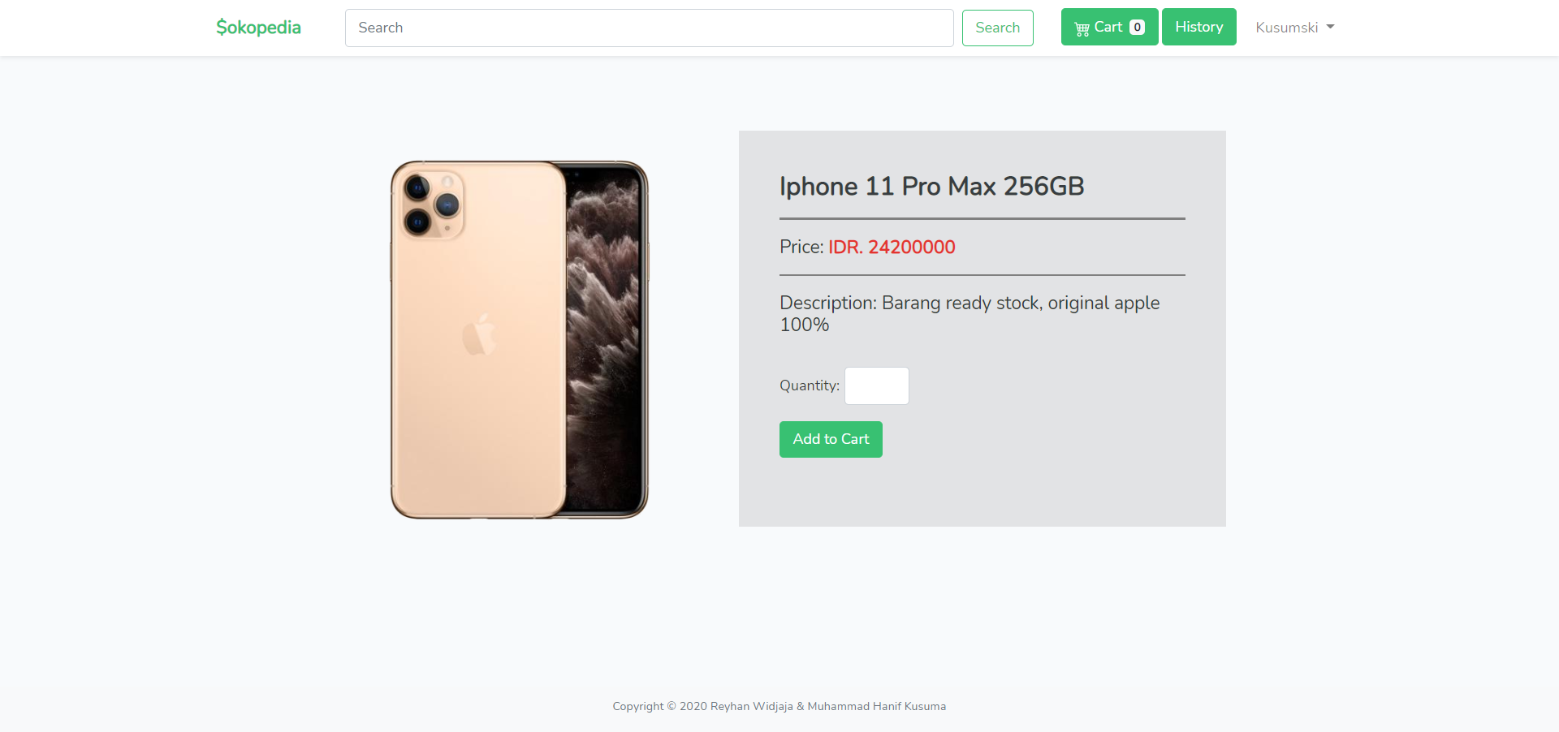

This page is accessible for **member only**. In this page, member can input **quantity** of product they want to add into cart and click **add to cart** **button**. Then, the product will be added to the cart and the cart counter will update. If members add a product that existed inside the cart, the quantity of the product in the cart will **change** **into the newest quantity inputted.**

1. Cart

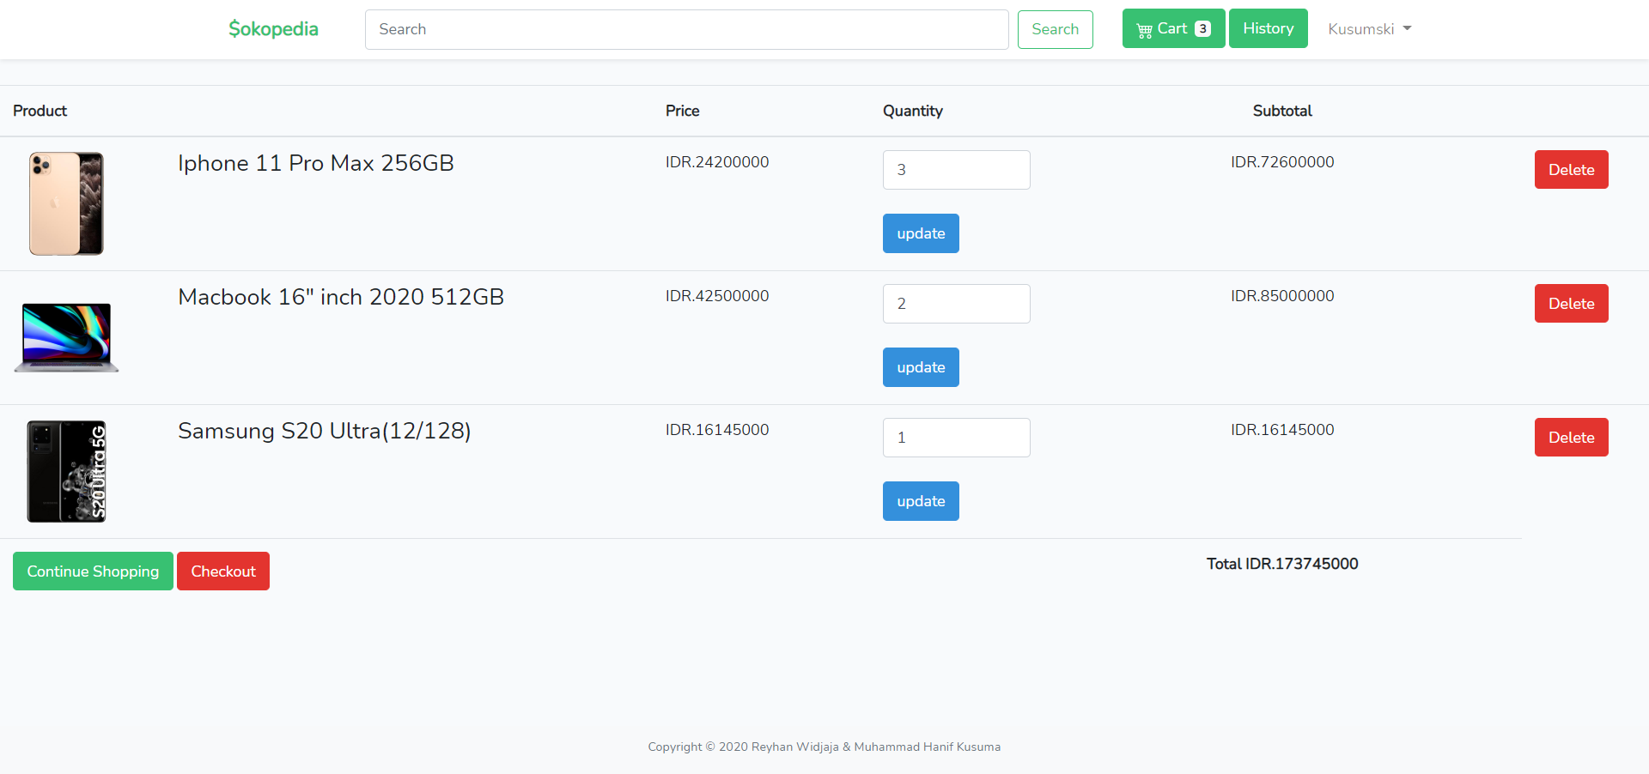

This page is accessible for **member only**. This page displays all product that added to cart, and including their **image**, **name**, **total price**, **quantity**. In this page, member can **delete** or **edit** **quantity** of their product in the cart or **Checkout** the cart, **validate** that Checkout button shown only when **cart not empty**. If member clicked **checkout** button, it would **clear** the cart, and **add** a new **transaction** in the **“History Page”.**

(**cart when empty)**

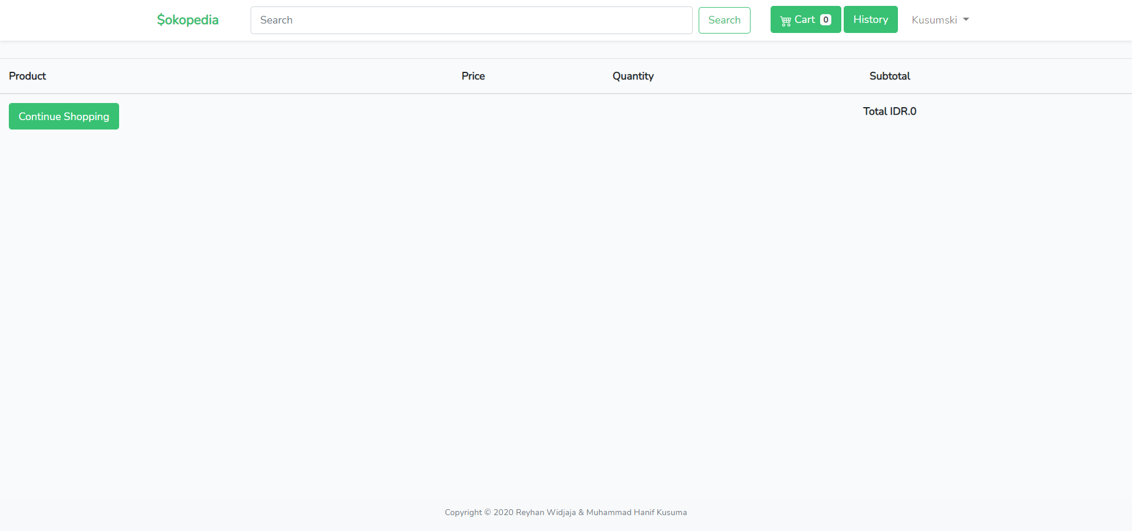

1. History

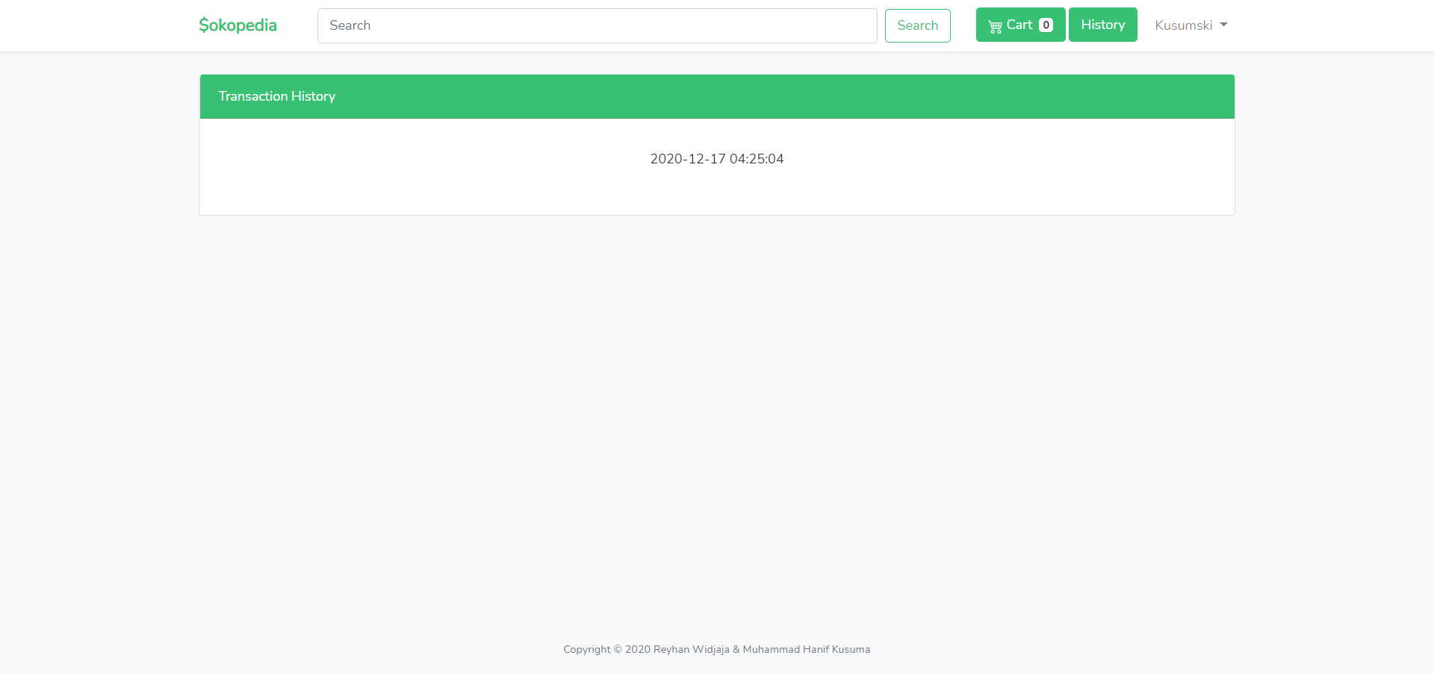

History page can be access by clicking **history** button beside cart, and only accessible for member. This page **displays all transaction date of current logged member**. Every transaction can be clicked and redirect to **“Detail Transaction Page”**

1. Detail Transaction

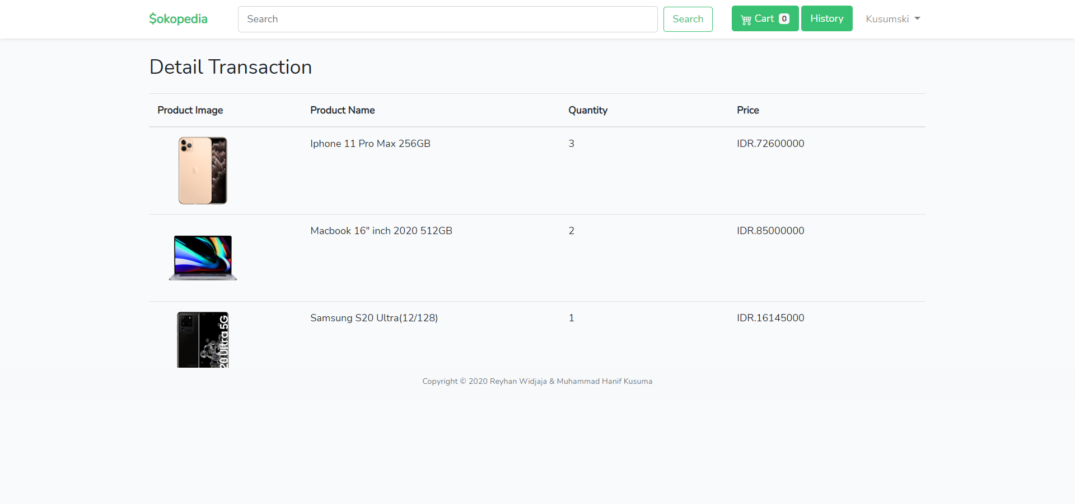

Detail transaction page displays all product bought in a transaction selected from History page. Every transaction detail must display **product** **image, name, total price, and quantity.**

1. Add Product

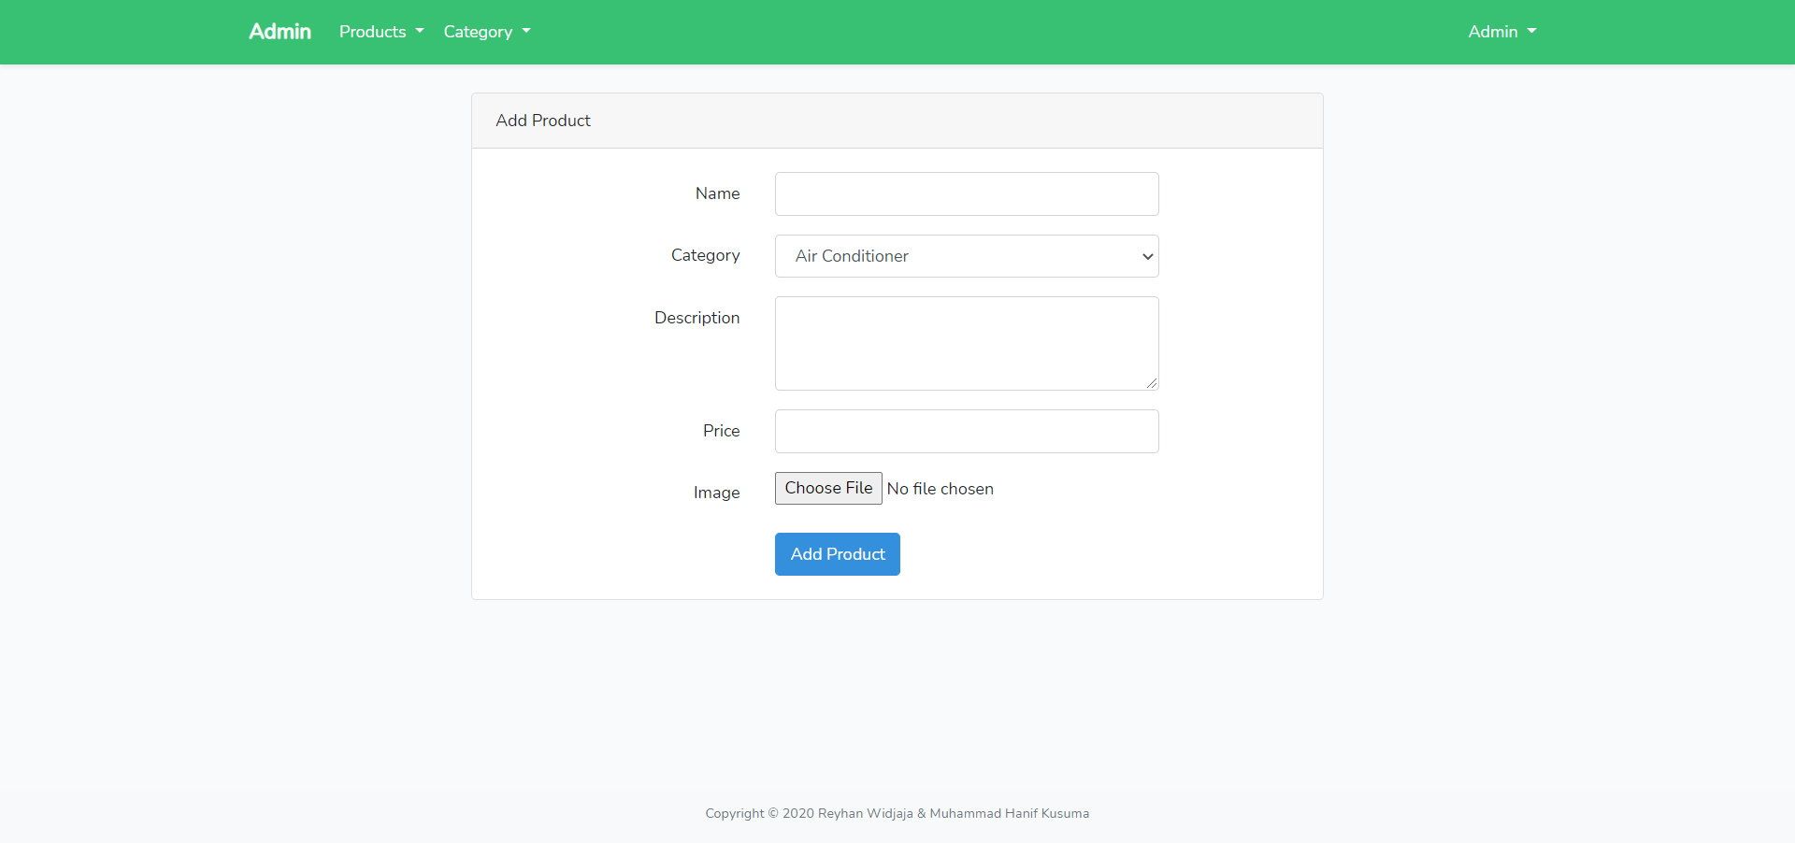

This page is only accessible for Admin. In this page, Admin can **add** new product. This page can be access when **Admin** choose “Add Product” Button.

1. List Product

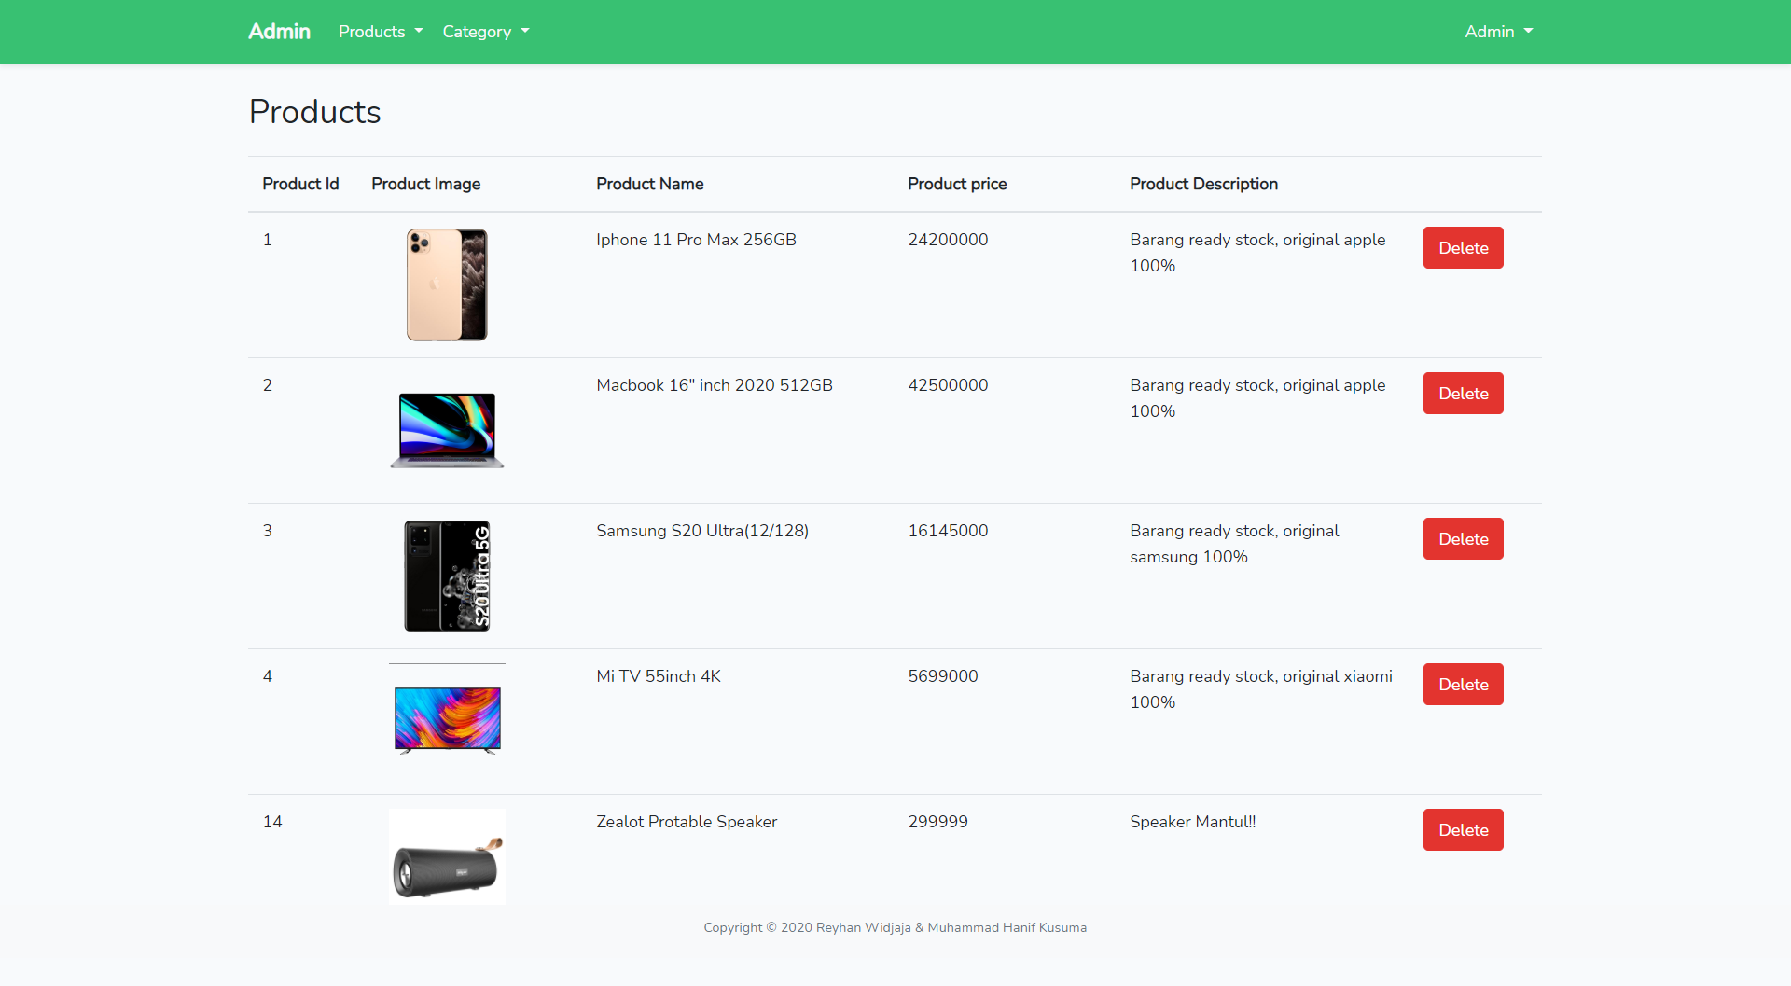

This page allows Admin to see all products. This page can be access when **Admin** choose “List Product” Button. There is also a “**Delete**” button in each product to delete the product. This page displays all product **image, name, price, description.**

1. Add Category

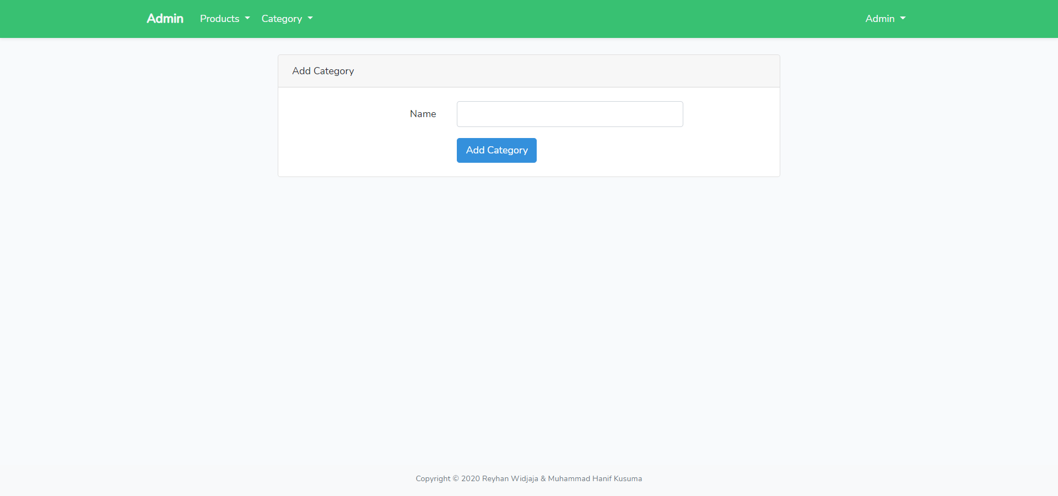

This page will allow **Admin** to add new product category, this page can be access when **Admin** choose “Add Category” Button.

1. List Category

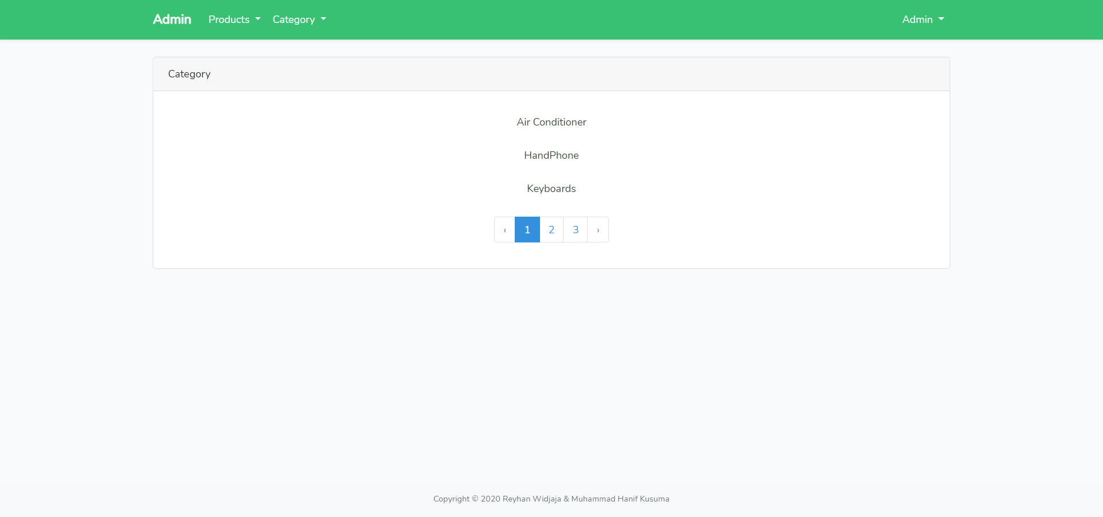

**(when “handphone” category is clicked)**

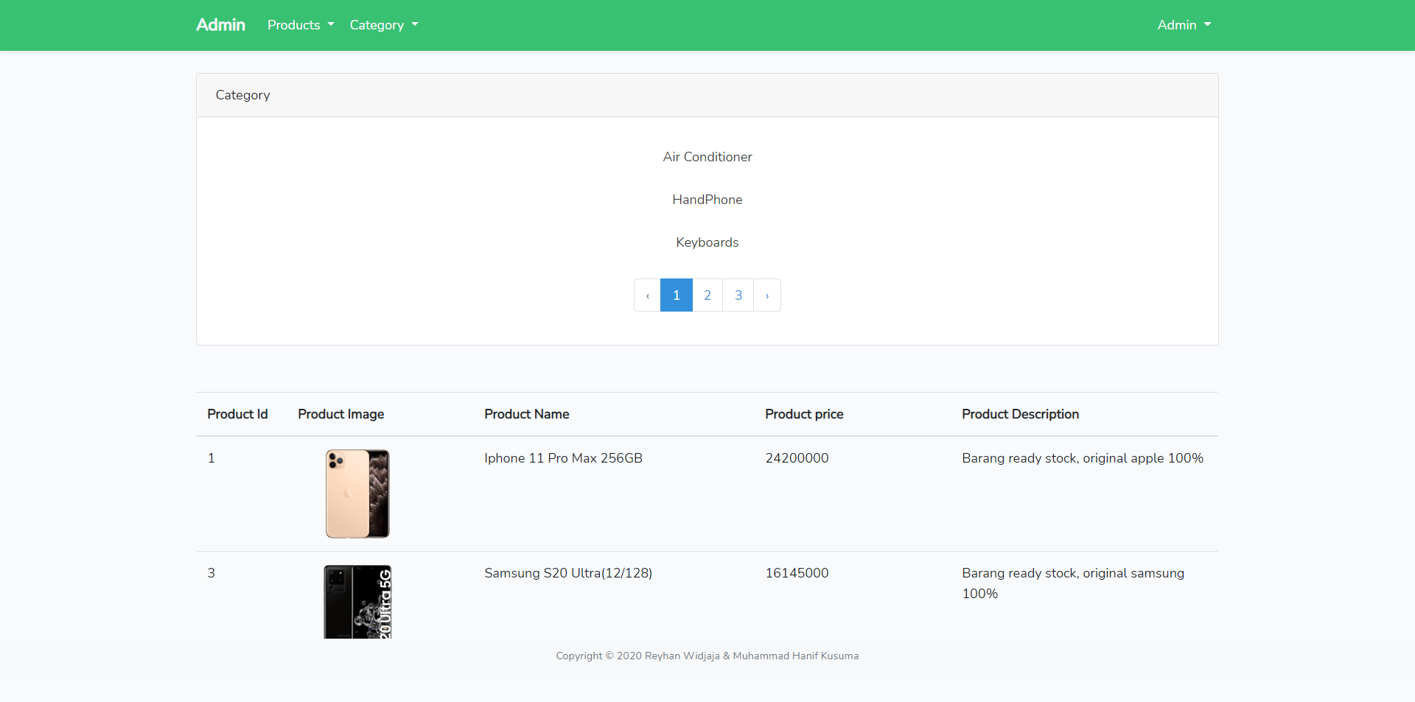

This page allows **Admin** to view all the product category. And each category can be clicked and show **product** by **category** clicked. Product information that must be displayed are **product id, product image, product name, product price, and product description**.

* Reference
* <https://tekno.kompas.com/read/2020/03/27/11530057/macbook-pro-16-inci-resmi-dijual-di-indonesia-harga-rp-36-juta>
* <https://www.movertix.com/en/samsung-galaxy-s20-ultra-5g-cosmic-black-128gb-and-12gb-ram-sm-g988b.html>
* <https://shopee.co.id/Xiaomi-Mi-TV-55-inch-4K-Android-9.0-smart-TV-Mi-55-UHK-SELAIN-BANDUNG-i.94409671.7926408833>
* <https://www.bhinneka.com/apple-iphone-11-pro-max-64gb-gold-sku3328750844>
* [https://www.jakartanotebook.com/zealot-portable-bluetooth-speaker-heavy-bass-s30-black#](https://www.jakartanotebook.com/zealot-portable-bluetooth-speaker-heavy-bass-s30-black)
* Group Member
* 2201781520 – Muhammad Hanif Kusuma
* 2201767604 – Reyhan Widjaja